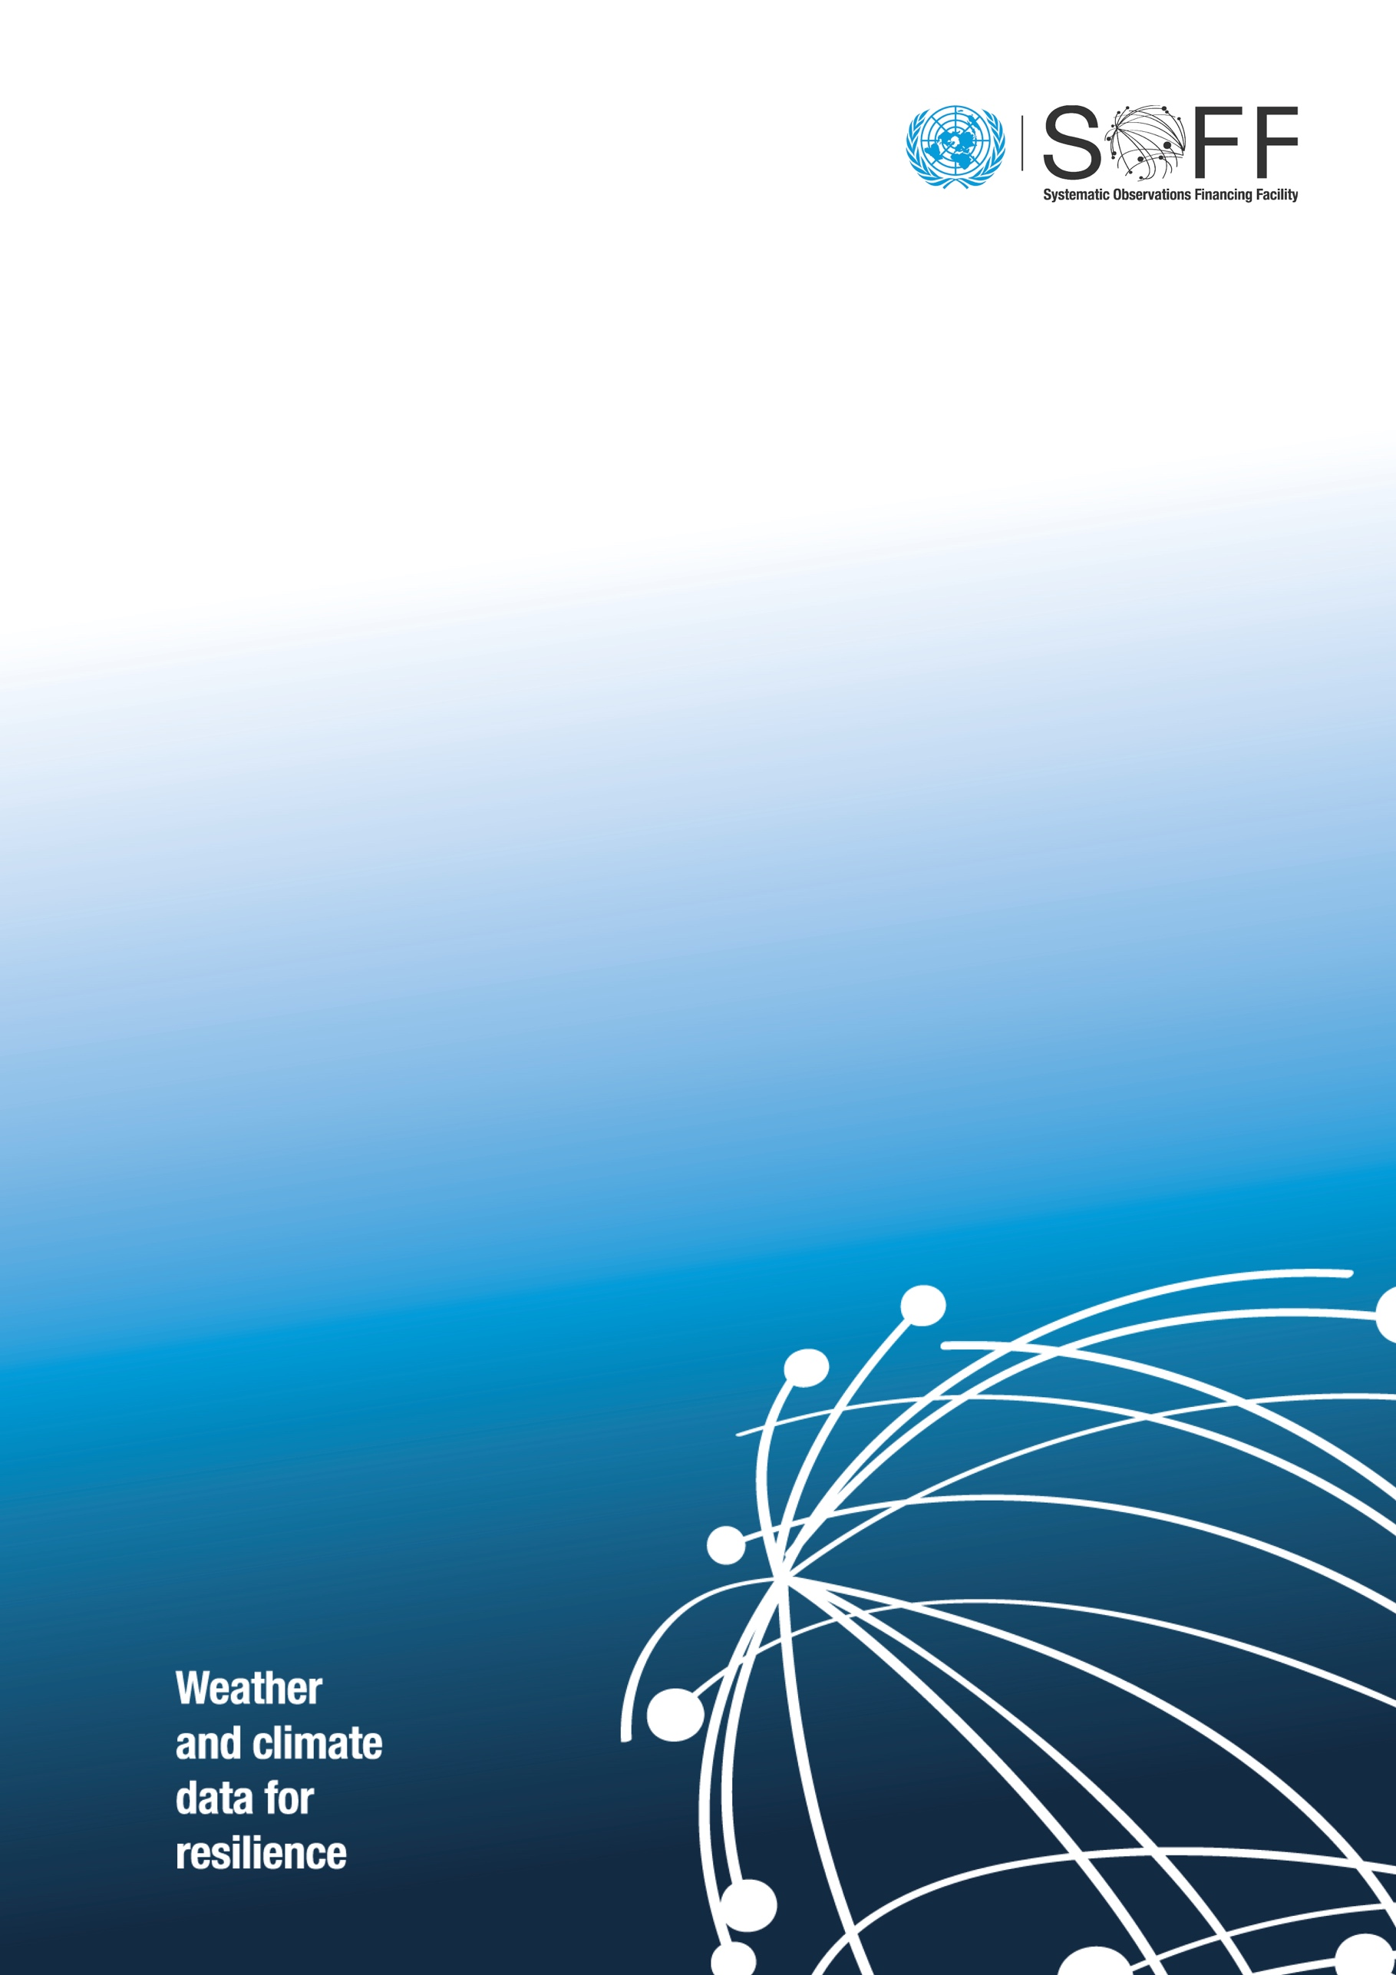

SOFF Investment Funding Requests

  - INF 12.3
  - Systematic Observations
Financing Facility
Twelfth Steering Committee
29 October 2025
Purpose of this Document
This document presents a summary of the SOFF Investment funding requests presented to the Steering Committee for inclusion in the Investment phase pipeline. Prioritization of the requests is in accordance with the approach to managing country funding requests outlined in Decision 11.6. The document provides the basis for Decision 12.2 on SOFF Investment funding requests.

Table of contents
1. Introduction 4
2. Investment phase pipeline and prioritization of funding requests 5
2.1. Dominican Republic 6
2.2. Suriname 8
2.3. Antigua and Barbuda 10
3. Operationalizing the collaboration framework for enhancing observation 12

SOFF Investment funding requests

Introduction
Following an iterative review by the SOFF Secretariat with inputs from the WMO Technical Authority, three new Investment funding requests are presented to the 12th Steering Committee meeting (12SC) for consideration.
In line with Decision 11.6, on the approach to managing country funding requests, the three additional funding requests are proposed to be included in the Investment phase pipeline, where submissions are batched and prioritized according to the prioritization criteria. As funds become available, Investment funding requests in the Investment pipeline will be submitted to the SOFF Steering Committee for funding decision and approval. The SOFF Investment Phase pipeline is publicly available on the SOFF website.
The table below presents the pipeline of Investment funding requests including the three new funding requests proposed for the pipeline.
Table 1. The Investment Phase pipeline including the proposed new batch of funding requests.
Batch | Order | Country | IE | Peer advisor | Duration (months) | Total budget requested (USD)
10SC | 1 | Zambia (phased) | WFP | UK | 60 | 3,627,540.00
10SC | 2 | Cuba | UNDP | Spain | 60 | 6,523,639.00
10SC | 3 | Bangladesh | IsDB | Norway–China | 60 | 4,954,865.00
11SC | 4 | Guyana | IDB | Austria | 36 | 1,931,350.00
11SC | 5 | Democratic Republic of the Congo (phased) | WFP | Switzerland | 36 | 2,459,982.52
11SC | 6 | São Tomé and Príncipe | UNDP | Netherlands | 60 | 2,907,084.07
12 SC | 7 | Dominican Republic | WFP | Spain | 36 | 1,281,021.62
12 SC | 8 | Suriname | UNDP | Netherlands | 48 | 2,666,810.60
12 SC | 9 | Antigua and Barbuda | UNDP | UK | 36 | 1,240,174.94
 |  | Total |  |  |  | $ 27,592,467.75
The three proposed pipeline Investment funding requests are expected to address 0.8% of the GBON gap for surface stations and 1.5% of the GBON gap for upper-air stations in Small Island Developing States (SIDS) and Least Developed Countries (LDCs). Together, the 18 countries with approved and conditionally approved Investment funding requests, and the nine pipeline Investment funding requests (Table 1), will result in SOFF investments addressing 44% of the GBON gap for surface stations and 42% of the GBON gap for upper air-stations over land in all SIDS and LDCs.
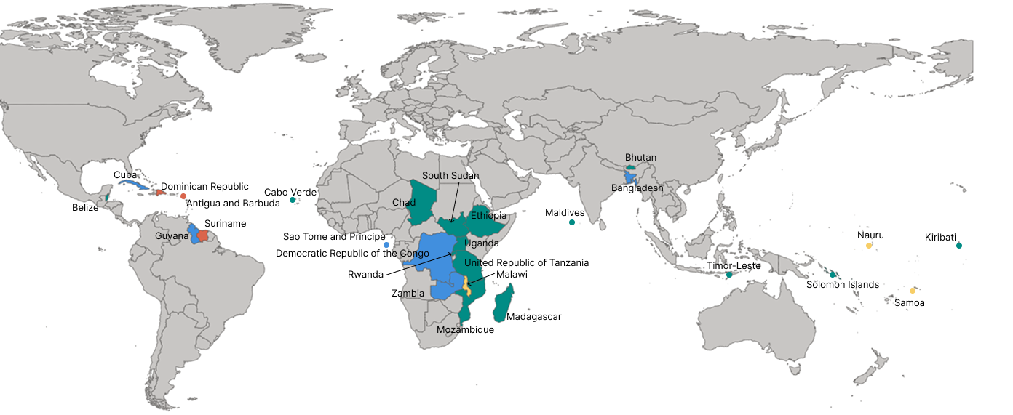
Figure 1. The map shows in green the 15 countries that have approved Investment funding requests, in yellow the three countries with conditionally approved funding requests, and in blue the six countries with funding requests in the pipeline. Countries in red are those with funding requests presented at the 12th SOFF Steering Committee meeting for inclusion in the pipeline.

Investment phase pipeline and prioritization of funding requests
This section outlines the proposed order of Investment funding requests that will be added to the current Investment phase pipeline. This is based on assessment of four criteria presented in Decision 11.6: technical feasibility, timing and scheduling, financial considerations, and risks. As not all criteria are applicable to every funding request, information is provided only where relevant.

Dominican Republic
Link |  | https://un-soff.org/document/investment-phase-pipeline-dominican-republic/
Implementing Entity |  | World Food Programme
Peer advisor |  | Agencia Estatal de Meteorología (AEMET), Spain
Implementation duration |  | 36
Phased approach |  | No
Budget requested |  | Total |  | USD 1,281,021.62
 |  | Activity costs |  | USD 1,123,801.76
 |  | Implementing Entity fee (6.5 %) |  | USD 73,047.11
 |  | Peer advisor fee (incl. WMO indirect cost) |  | USD 84,172.75
Status of surface stations for June 2023 as shown in the WDQMS webtool
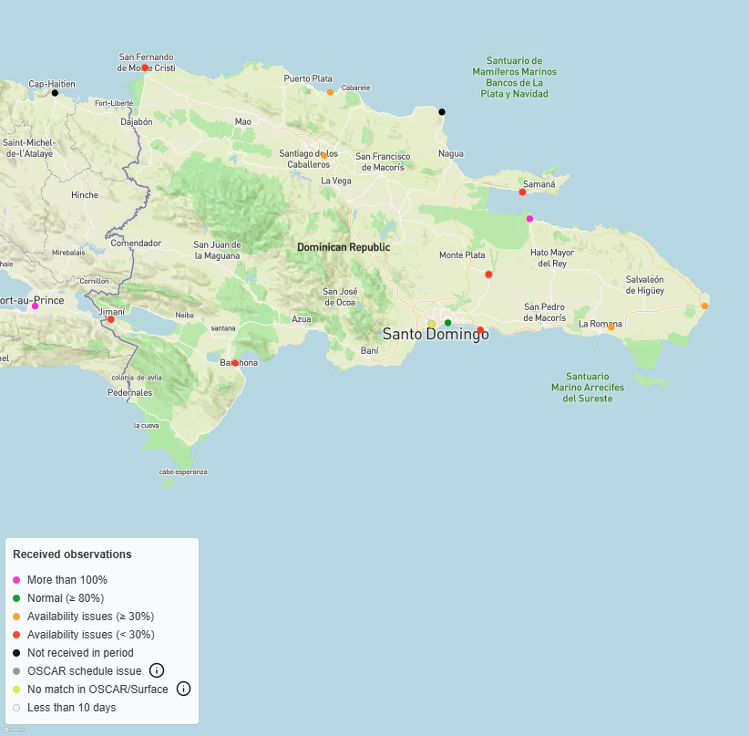
Overview of the stations to be installed and/or improved
 | WMO GBON Global Gap Analysis June 2023 |  | National Contribution Plan
 | Target |  | Gap new | Gap improve
Surface | 2 |  | 0 | 4
Upper-air | 1 |  | 0 | 0
Dominican Republic is ranked first in the proposed third batch of SOFF Investment funding requests pipeline given the strong leveraging opportunities in the country that make only modest investments necessary to achieve full GBON compliance.
Technical feasibility: Dominican Republic is well positioned to achieve GBON compliance supported by its recent institutional upgrade to the Dominican Meteorological Institute, strong regional partnerships through CIMHET, and infrastructure that mainly requires upgrade and sustainability support. Complementary initiatives, including National Oceanic and Atmospheric Administration’s (NOAA) support to the upper-air station, the Inter-American Development Bank - financed data management system, and WFP’s Anticipatory Actions Project, further reinforce sustainability. With WFP as a potential implementing partner of CREWS initiative in Dominican Republic (currently under development), alignment with SOFF is ensured. The main gap in Dominican Republic as presented in their National Contribution Plan and Country Hydromet diagnostics is gaps in institutional and human capacity particularly in technical maintenance and project management, which the SOFF Investment phase will address.
While the WMO Global Gap Analysis (June 2023) set a target of 2 surface stations and 1 upper air station over land for the country, the assessments conducted during the Readiness phase identified the need of 4 surface stations to adequately meet the GBON resolution given the geography of the country. The existing upper air receives support from NOAA and no SOFF support is requested at this stage.
Risk assessment: The funding request notes that successful implementation of SOFF investments may be at risk due to human and institutional capacity constraints. Several activities in the Investment phase are designed to address these gaps while also serving as incentives to retain local staff and reduce turnover.

Suriname
Link |  | https://un-soff.org/document/investment-phase-pipeline-suriname/
Implementing Entity |  | UNDP
Peer advisor |  | Royal Netherlands Meteorological Institute (KNMI)
Implementation duration |  | 48 months
Phased approach |  | No
Budget requested |  | Total |  | USD 2,666,810.60
 |  | Activity Budget |  | 2,265,587.60
 |  | Implementing Entity Fee |  | 158,591.13
 |  | Peer advisor fee (incl. WMO indirect cost) |  | 242,631.87
Status of surface stations for June 2023 as shown in the WDQMS webtool
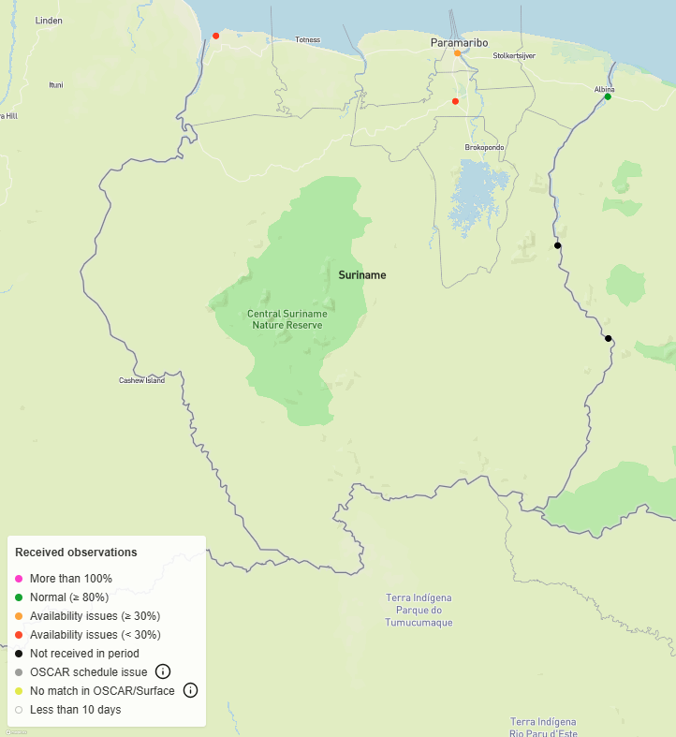
Overview of the stations to be installed and/or improved
 | WMO GBON Global Gap Analysis June 2023 |  | National Contribution Plan
 | Target |  | Gap new |  | Gap improve
Surface | 2 |  | 1* |  | 4
Upper-air | 1 |  | 0 |  | 1
* A new AWS co-financed by the Government of India has already been installed and is now included in the Investment funding request to be upgraded with SOFF support (in addition to the 4 improve surface stations).
Suriname is ranked second in the current proposed Investment funding request pipeline due to its potential to deliver broader regional benefits to the Caribbean and the Amazon region.
Technical feasibility: Suriname is well positioned to achieve GBON compliance, building on its existing surface and upper-air network, strong regional partnerships in the Caribbean as well as the completed co-financing contribution from the Government of India. As a continental country with a much larger land area than most SIDS, Suriname requires more than the WMO Global Gap Analysis (June 2023) baseline of two surface and one upper-air station. Currently, none of its stations are GBON compliant.
Readiness assessments confirmed the need to upgrade four strategically located surface stations and one upper-air station to achieve full GBON compliance. In addition, a fifth AWS, originally planned for new installation with support from Government of India has since been installed. This station is now proposed for upgrade under SOFF investments in anticipation of sensor replacements within 2–3 years due to environmental conditions in Suriname ensuring sustainability of the investment. Investments also include capacity building at the institutional and technical level as well as the investment in a value proposition analysis based on increased capacities of the National Meteorological Service (MDS- Meteorological Service Suriname).
Successful implementation will also deliver broader regional benefits for the Caribbean and Amazon by enhancing observational capacity and contributing to the global exchange of data. These efforts will complement other regional initiatives such as the Caribbean-CREWS initiative, Caribbean Institute for Meteorology & Hydrology (CIMH), Caribbean Climate Outlook Forum (CARICOF), and the Regional Climate Centre.
Risk assessment: Key risks include financial sustainability, staff turnover, and operational delays, with most others assessed as low to medium. Mitigation focuses on diversified funding, capacity building, and strong project management to ensure timely implementation and long-term GBON compliance.

Antigua and Barbuda
Link |  | https://www.un-soff.org/document/soff-investment-phase-pipeline-antigua-and-barbuda/
Implementing Entity |  | United Nations Development Programme
Peer advisor |  | Met Office [United Kingdom]
Implementation duration |  | 36 months
Phased approach |  | No
Budget requested |  | Total |  | USD 1,240,174.94
 |  | Activity costs |  | USD 1,034,500.00
 |  | Implementing Entity fee |  | USD 72,415.00
 |  | Peer advisor fee (incl. WMO indirect cost) |  | USD 133,259.94
Status of surface stations for June 2023 as shown in the WDQMS webtool
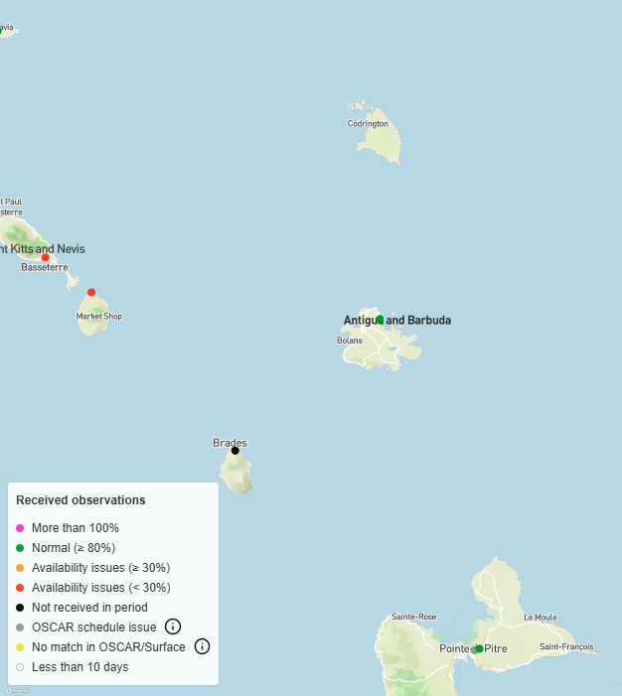
Overview of the stations to be installed and/or improved
 | WMO GBON Global Gap Analysis June 2023 |  | National Contribution Plan
 | Target |  | Gap new |  | Gap improve
Surface | 1 |  | 0 |  | 1
Upper-air | 1 |  | 0 |  | 0
Antigua and Barbuda is ranked third in the Investment funding request pipeline. While its surface station and IT infrastructure requires improvements to ensure long-term sustainability, the country’s main needs for SOFF support, focused on institutional and human capacity building, are assessed to be comparatively less immediate than those of the other countries in this batch.
Technical feasibility: The WMO Global Gap Analysis (June 2023) baseline identified one surface station and one upper-air station as GBON targets for Antigua and Barbuda. However, the WMO Regional Association IV (North America, Central America and the Caribbean) meeting agreed on establishing a regional GBON upper-air network, meaning Antigua and Barbuda is not required to operate its own upper-air station. Further, the surface station was occasionally GBON complaint (between June 2023 and December 2024), but Readiness phase assessment identified the need for support to ensure sustainability of the station.
The most critical gaps are institutional sustainability and human capacity, particularly for calibration, operation, and maintenance. ABMS is operating at overstretched capacity, with limited national funding largely covering staff costs, making its reliance on project-based support unsustainable. As a result, ABMS requires a higher level of investment to address these institutional and human capacity gaps. SOFF support will therefore focus on strengthening government support and recognition for ABMS through a socioeconomic benefit analysis, alongside targeted capacity building in calibration, operation, and maintenance. Importantly, SOFF investments are designed to complement larger ongoing projects, notably the USD 12.3 million (USD 2.5 Million dedicated to ABMS) EW4All Green Climate Fund project (implemented by UNDP), which will strengthen ABMS’s regulatory framework, forecasting, and financial sustainability. SOFF will align with these efforts by ensuring data quality, contributing to GBON, and supporting ABMS’s Strategic and Operations Plan.
Risk assessment: Key risks for Antigua and Barbuda include station operations and hardware failure, staff capacity gaps, political misalignment, financial management, and exposure to natural disasters. Mitigation focuses on adequate funding, redundancy measures, staff training, UNDP’s financial oversight, and integrating sustainability and resilience into ABMS operations and infrastructure.

Operationalizing the collaboration framework for enhancing observation
SOFF investments are designed to leverage synergies with key multilateral climate funds, including the Adaptation Fund (AF), Climate Investment Funds (CIF), Green Climate Fund (GCF), Global Environment Facility (GEF), and the Climate Risk and Early Warning Systems (CREWS), to enhance the effectiveness and sustainability of investments in systematic observations. The SOFF Secretariat, together with the Secretariats of these five funds, signed a Framework for Collaboration for enhancing systematic observation and improving the use of essential weather and climate data for effective climate action. This framework seeks to further enhance complementarity by leveraging the work of SOFF to support better climate information services and early warning systems.
Potential areas for further synergies in these countries and the operationalization of the Collaboration Framework through SOFF investments have been identified and summarized in the table below:

Table 2. Overview of the operationalization of the SOFF Collaboration Framework with the multilateral climate funds through the funding requests.
Batch | Order | Country | Climate fund | Project title | Status | Financing amount
12 SC | 1 | Dominican Republic | GEF | Land Degradation Neutrality for Increased Resilience to Climate Change in Dominican Republic | Approved | $4,835,750 | $4,835,750
12 SC | 2 | Antigua and Barbuda | AF | AF00000370 | Under implementation | $1,932,000 | $37,163,317
12 SC | 2 | Antigua and Barbuda | GCF | FP258 Multi-country Project Advancing Early Warnings for All (EW4All) | Approved | $2,524,722 | $37,163,317
12 SC | 2 | Antigua and Barbuda | GCF | FP133  Resilience to hurricanes in the building sector in Antigua and Barbuda | Under implementation | $32,706,595 | $37,163,317
12 SC | 3 | Dominican Republic Suriname and Antigua and Barbuda | CREWS | CREWS Caribbean 2.0 (Caribbean Regional project total 19 countries) | Under implementation |  | $7,000,000

Abbreviations: IE = Implementing Entity; IDB = Inter-American Development Bank; IsDB = Islamic Development Bank; UNDP = United Nations Development Programme; WFP = World Food Programme
15 countries have approved Investment funding requests namely Belize, Bhutan, Cabo Verde, Chad, Ethiopia, Kiribati, Madagascar, Maldives, Mozambique, Rwanda, Solomon Islands, South Sudan, Timor-Leste, Uganda, and United Republic of Tanzania. In addition, three countries have conditionally approved funding requests namely Samoa, Nauru, and Malawi.
Conference of the National Ibero-American Meteorological and Hydrological Services
Suriname National Contribution Plan (2024),

