**Summary of SOFF Caribbean Regional Workshop – Session 5: Regional Capabilities**

**Introduction:** Following a panel discussion on the potential for regional designs and shared capabilities to underpin GBON delivery in the Caribbean region, Ali Price (UK Met Office) and Greta Aubke (World Food Programme) led a session asking NMS representatives to define their key requirements in this respect. Voting was initiated on the 8 main topics discussed by the panel via Mentimeter, asking the following questions:

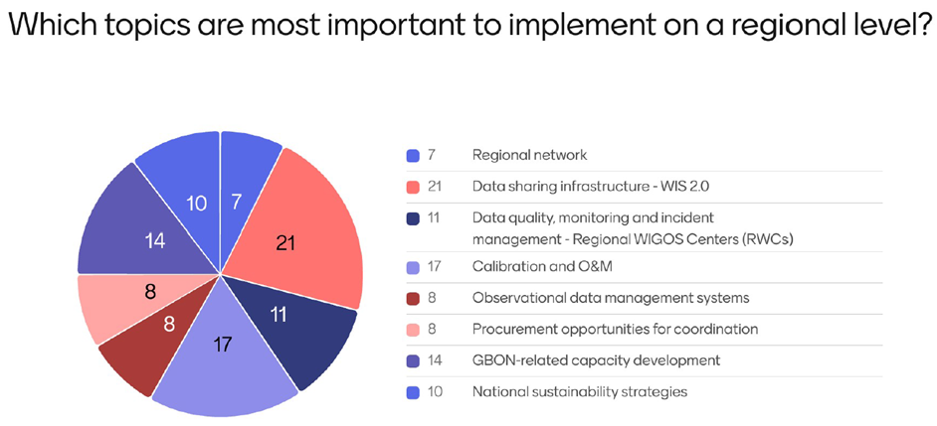

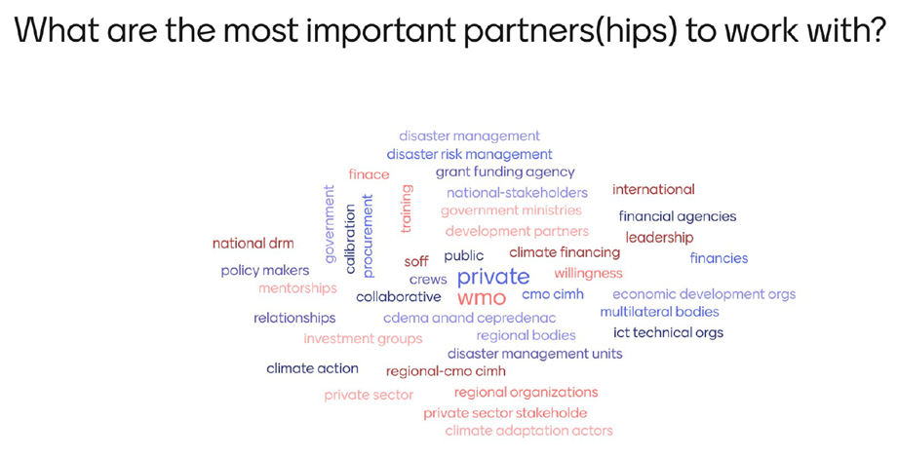

Participants were then asked to take three highest scoring requirements and discuss within 4 groups of participants (made up of NMSs, Peer Advisors and Implementing Entities) – those top three requirements were:

* Data sharing infrastructure – WIS 2.0
* Calibration and O&M
* GBON-related (human) capacity development

Participants were also asked to complete their full national requirements via a spreadsheet template provided by email.

**Group discussion outcomes - Key conclusions:**

**Group 1:**

* *Data sharing and infrastructure:* Sustainability/funding of regional WIS 2.0 node is key – need to understand costs. Individual NMSs do not have expert capacity, implement via CMO/CIMH - regional SurfaceCDMS collaboration is a mechanism to do this
* *Calibration and O&M:* A regional spares & calibration facility is important – however, challenges of sending sensors away, so spares facility in-country also needed; mobile technicians would be beneficial
* *Capacity development:* Need regional training and workshops for technicians; need to better support CIMH and expert recruitment
* Sharing of best practice and a mechanism for NMSs to meet frequently would benefit
* How can SOFF assist with these?

**Group 2:**

* *WIS 2.0:* Establishing a pool of trained ICT professionals and establishing a community of practice is important – there should be regular meeting opportunities, sharing key technical documents and information
* *Calibration:* Should build capability on a sub-regional level, ie - CIMH and Cuba, but all NMSs should have calibration kits. Larger NMSs could develop some calibration services to supplement this
* *Capacity Development:* Need for regional training and documentation/training manual, notably on ICT. PR training on leveraging funding from national governments. Succession planning required, dependant on resources
* There is a strong need for WMO and CMO to help NMSs to communicate the value of met services (SEB) to get sustainable support from their government

**Group 3:**

* *WIS 2.0:* Establish a focus group, develop a pool of trained personnel. Common data sharing protocols would allow for regional data sharing approach
* *Calibration & Spares:* Regional sharing of spare parts using eg existing CIMH spares database would achieve an economy of scale and reduce costs. Calibration is a challenge as SOFF only currently supports national capabilities rather than a regional calibration centre
* *Capacity Development:* NMSs need technical expertise and regional guidance and training. Develop a competence framework for the region?
* Work together on maintenance and training – current CMO/CIMH model

**Group 4:**

* *WIS 2.0:* Sustainability for WIS 2.0 node is an issue – need resources and knowledge transfer rather than rely on individuals (eg SurfaceCDMS)
* *Calibration:* CIMH and Cuba are existing centres (*CIMH/Barbados is an existing RIC)
* *Capacity Development:* CIMH and Cuba perform training roles according to train-the-trainer principle. Training only successful if organised on a regional basis
* SOFF needs a mechanism to transfer funds to regional institutions

**Common themes?**

* Regional collaboration is key for sharing best practice and ensuring sustainability, achieving economies of scale and saving cost
  + WIS 2.0 collaboration is key including sustainability of the WIS 2.0 Node/SurfaceCDMS, use of common protocols for data sharing and development of expert ICT resource across the community
  + There is a need for regional calibration/spares centres, supported by local spares holdings and field calibration in-country
  + Technical training should be coordinated regionally via existing centres; a forum to meet and a community of practice should be established with expertise spread more widely. Training for PRs for engaging national governments would also be beneficial to showcasing NMS value
* CMO/CIMH and Cuba already provide some regional capability across these requirements
* Participants consider there to be a role for SOFF in helping to fund regional institutions – need mechanisms for transfer of funds

**Annex – Full group discussion summaries**

**Group 1**

The meeting discussed strategies to facilitate online groupings and improve data exchange infrastructure. Key points included the need for a common data format, with pilot countries having multiple formats. The importance of data storage and effective use was emphasized. The sustainability of WMO 2.0 was debated, with funding ending in 2027 and an annual cost of $1,000 USD for cloud maintenance. Capacity development was highlighted, suggesting training for technicians and incorporating national partners. The use of online platforms for collaboration and the need for regular technician meetings were also discussed. The meeting concluded with a focus on calibration and operation maintenance strategies.

Action Items

* Develop a plan for the long-term sustainability of the WIS 2.0 regional node, including funding mechanisms.
* Explore opportunities to leverage national resources, such as universities and government IT divisions, to support capacity development.
* Investigate the feasibility of creating an online platform for technicians to collaborate, share best practices, and troubleshoot issues.
* Organize regular in-person meetings for technicians to discuss issues and share experiences.
* Establish a regional spares facility and process for calibrating and maintaining instruments.

Outline

Implementation of Surface and Financial Component

* Speaker 1 asks about facilitating informal groupings online and the financial component for countries seeking assistance.
* Speaker 2 explains the need for a forum where everyone is physically present to assist with implementing Surface.
* Discussion on the financial aspect of funding structures recommended by Dwayne for countries without the necessary IT infrastructure.
* Speaker 2 mentions the development of a common data format and the need for a decoder to translate different formats into a centralized one.

Development of Central Data Format

* Speaker 2 emphasizes the importance of using the existing data format built into Surface to avoid creating another format.
* Discussion on the need for a centralized system to handle multiple data formats and integrate them for numerical weather predictions and decision-based analysis.
* Speaker 3 suggests building a regional standard with a limited number of in-country formats that Surface can translate and communicate internationally.
* Speaker 2 highlights the end goal of implementing WMO 2.0 and the need to integrate other tools and services to achieve this.

Sustainability of WMO 2.0 and Funding Mechanisms

* Speaker 4 mentions the funding for the regional node up to 2027 and the need for a long-term sustainability plan.
* Speaker 2 inquires about the cost of maintaining the cloud and the need for a financial mechanism to support it.
* Speaker 3 explains that the funding will transition to an annual cost of around $1000 USD to maintain the cloud.
* Discussion on the role of SOFF in supporting the region and the need for self-sufficiency and self-reliance in terms of financial and technical assistance.

Capacity Development and Training

* Speaker 5 asks about SOFF’s role in capacity development for data sharing platforms and maintenance of instruments.
* Speaker 1 suggests funding training and support for CIMH and recruiting experts with a competent background.
* Discussion on the challenge of introducing new structures and the need for human resources to deliver on these initiatives.
* Speaker 2 proposes incorporating national partners, including technical institutions, to identify individuals in the computer science realm to assist with the work.

Collaboration with National Stakeholders

* Speaker 3 emphasizes the importance of collaborating with national ICT divisions and leveraging national resources in ICT.
* Speaker 6 mentions the opportunity to use interns from CREF to support the efforts.
* Discussion on the need for training workshops to build regional capacity and support the efforts of the institute.
* Speaker 3 highlights the importance of having a pool of experts to move around and support the regional efforts.

Online Collaboration and Mobile Technicians

* Speaker 3 suggests replicating an online platform similar to the CMO operational radar group for technicians to share issues and best practices.
* Speaker 8 raises concerns about the cost of travel for technicians and the need for mobile technicians.
* Speaker 3 mentions the use of online collaboration platforms and the importance of face-to-face training sessions.
* Discussion on the need for technicians to meet and discuss issues and best practices regularly.

Calibration and Operation and Maintenance

* Speaker 2 discusses the process of calibration and the need for a spares facility region-wide and country-wide.
* Speaker 2 explains the challenges of sending sensors off for calibration and the need for an acclimatization period in the lab.
* Discussion on the importance of having the necessary skills and resources to make adjustments during calibration.
* Speaker 1 asks if CMH has a strategy to resolve and sustain the calibration issue and the role of SOFF in this strategy.

**Group 2**

**Group 3**

1. Can we use existing CMO/CIMH, other regional structures?
2. Suriname in RAIII was not a part of the training in WIS – We need to find out if there is any other regional training in WIS 2. For those without WIS implemented, it is better to synergize harmonise with the Caribbean existing model. - CMO has basic template that the director signs. In the discussion at the table CMO has agreed to send the form to the PR of Suriname to sign to start the process of WIS2 implementation.
3. At the Caribbean Met Council recently approved the formation of a WIS2 focus group comprised of WIS2 trained personnel to assist with WIS2 implementation. This will help guide with the technical capacities, tech specs and other countries in the Caribbean.
4. **What can we do well together** The existing Spare parts database from CIMH will offer a solution with much needed spare parts in the region, esp when funding for new parts may not be available and also shared spare parts will reduce costs.
5. **Obstacles:** Calibration deficiencies in the region , SOFF can only fund the beneficiary country and not the calibration centre (was proposed by SOFF secretariat). Data sharing protocols , infrastructure , GBON allows for easy data sharing, but the wider network,
6. What do we need: Technical expertise, guidance, more collaboration, current station. Work together for the maintenance, use current model is CMO or CIMH facilitate the training and invite the countries to participate

**Group 4**

