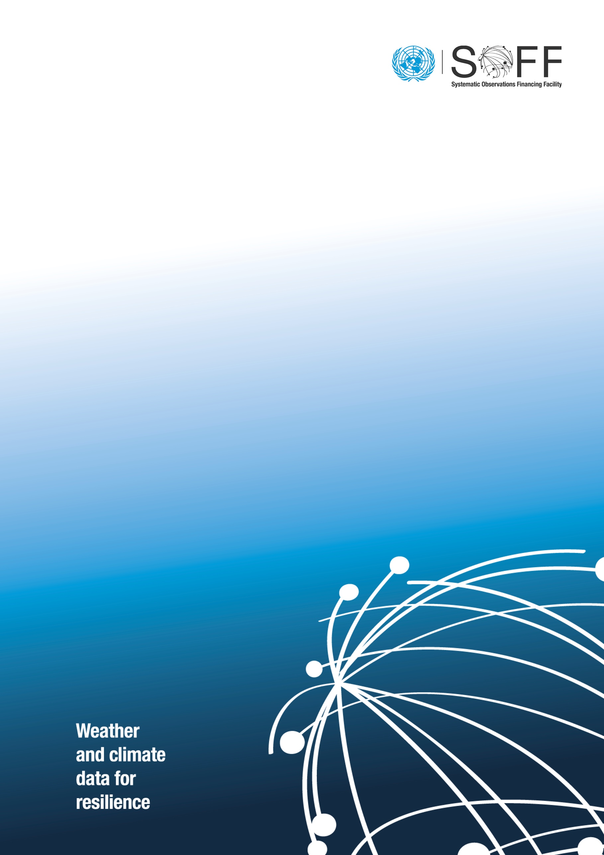
GBON National Gap Analysis Report

GBON National Gap Analysis

  - [Country]
  - Systematic Observations
Financing Facility
[date and month] 2025
[Country Name]

Country Focal Point and Institute
Peer Advisor Focal Point and Institute

Country information from the GBON Global Gap Analysis
Please provide in this Table the country information as provided by the WMO Global GBON Gap Analysis.
Table 1. WMO GBON Global Gap Analysis (June 2023). Illustration of the information that the WMO Secretariat provides to each country.
A. GBON horizontal resolution requirements | B. Target | C. Reporting (GBON compliant) | D. Gap to improve | E. Gap new | F. Gap total
 | [# of stations]
Surface stations
Standard density 200 km
Upper-air stations over land
Standard density² 500km

Analysis of existing GBON stations and their status against GBON requirements
Please complete the two tables below and add remarks and Annexes with technical details as needed.
Table 2. Assessment of existent stations per their operational status and network ownership.
GBON Requirements | Existing observation stations (# of stations)
 | NMHS network |  | Third-party network
 | Reporting (GBON compliant) ¹ | To improve | Reporting (GBON compliant) ² | To improve
Surface land stations Standard density ² 200km Variables: SLP, T, H, W, P, SD
Upper-air stations operated from land Horizontal resolution²: 500km
Vertical resolution: 100m, up to 30 hPa
Variables: T, H, W
Surface marine stations in Exclusive Economic Zones:³ 500 km
Variables: SLP, SST
Upper-air stations operated in Exclusive Economic Zones: 1000 km
Vertical resolution: 100m,
up to 30 hPa
Variables: T, H, W

Table 3. Assessment of existing GBON stations per station characteristics.
Station name | Station type (S/UA/M) | Owner (NMHS/3rd party) | Funding source | GBON variable measured |  |  |  |  |  |  | Reporting cycle (obs/day) |  | GBON Compliant (Y/N)
 |  |  |  | SLP | T | H | W | P | SD | SST
Station type: S: Surface, UA: Upper-Air; M: Marine; Owner of the station: NMHS or name of third-party; GBON variables: SLP: Atmospheric pressure; T: Temperature; H: Humidity; W: wind; P: Precipitation; SD: Snow depth; SST: Sea surface temperature; Reporting cycle: Number of observation reports exchanged internationally per day (0-24); GBON compliance: whether the station is GBON compliant or not (see GBON guide on compliance criteria).

Results of the GBON National Gap Analysis
Please complete the two tables below and add remarks and technical details in Annexes as needed.
Table 4. Results of the GBON national gap analysis.
GBON requirements | Global GBON target | Approved national target | GGBON compliant | Gap
 |  |  |  | To improve | New
 | [# of stations]
Surface land stations
Upper-air stations operated from land

Surface marine stations in Exclusive Economic Zones:³
Density 500 km
Variables: SLP, SST
Observing cycle: 1h
Upper-air stations operated in Exclusive Economic Zones: ³ Density 1000 km
Vertical resolution: 100 m,
up to 30 hPa
Variables: T, H, W
Observing cycle: twice a day
SLP: Atmospheric pressure; T: Temperature; H: Humidity; W: wind; P: Precipitation; SD: Snow depth; SST: Sea surface temperature.

Recommended existing surface, upper-air and marine⁴ stations to be designated to GBON
Table 5. Recommended existing surface, upper-air and marine stations to be designated to GBON.
Station name | Station type (S/UA/M)

[**Add here (i) a map of existing surface and upper-air stations with 200km/500 (diameter) km circles (500km/1000km for SIDS that are Small Island States) to indicate the coverage of existing stations; and (ii) optional: Include newly proposed stations in the map in (i) **]

Report completion signatures
Peer Advisor signature

Country signature

WMO Technical Authority

The rationale for classifying surface and upper-air stations as reporting is based on the WIGOS Data Quality Monitoring System (WDQMS) for the chosen time period (WMO GBON Global Gap analysis, June 2023). Stations with data availability more than 80% on at least 80% of days, are considered as reporting. Other listed stations are counted as having the possibility to be improved.
For Small Island States that have a significantly larger EEZ area than land surface area, for the WMO GBON Global Gap Analysis in June 2023, the EEZ area has been added to the total surface area which is the basis for the target number of stations. The standard density requirements for these Islands have been calculated with 500 km for surface stations and 1000 km for upper-air stations.
Although GBON marine stations and stations in EEZ are not part of initial SOFF scope, peer advisors are encouraged to analyze in this step when considered relevant e.g. SIDS, the status of current marine stations for future GBON marine observations investments.
Please see guidance on marine stations in Section 2 on Scope.
Please see guidance on marine stations in Section 2 on Scope.

