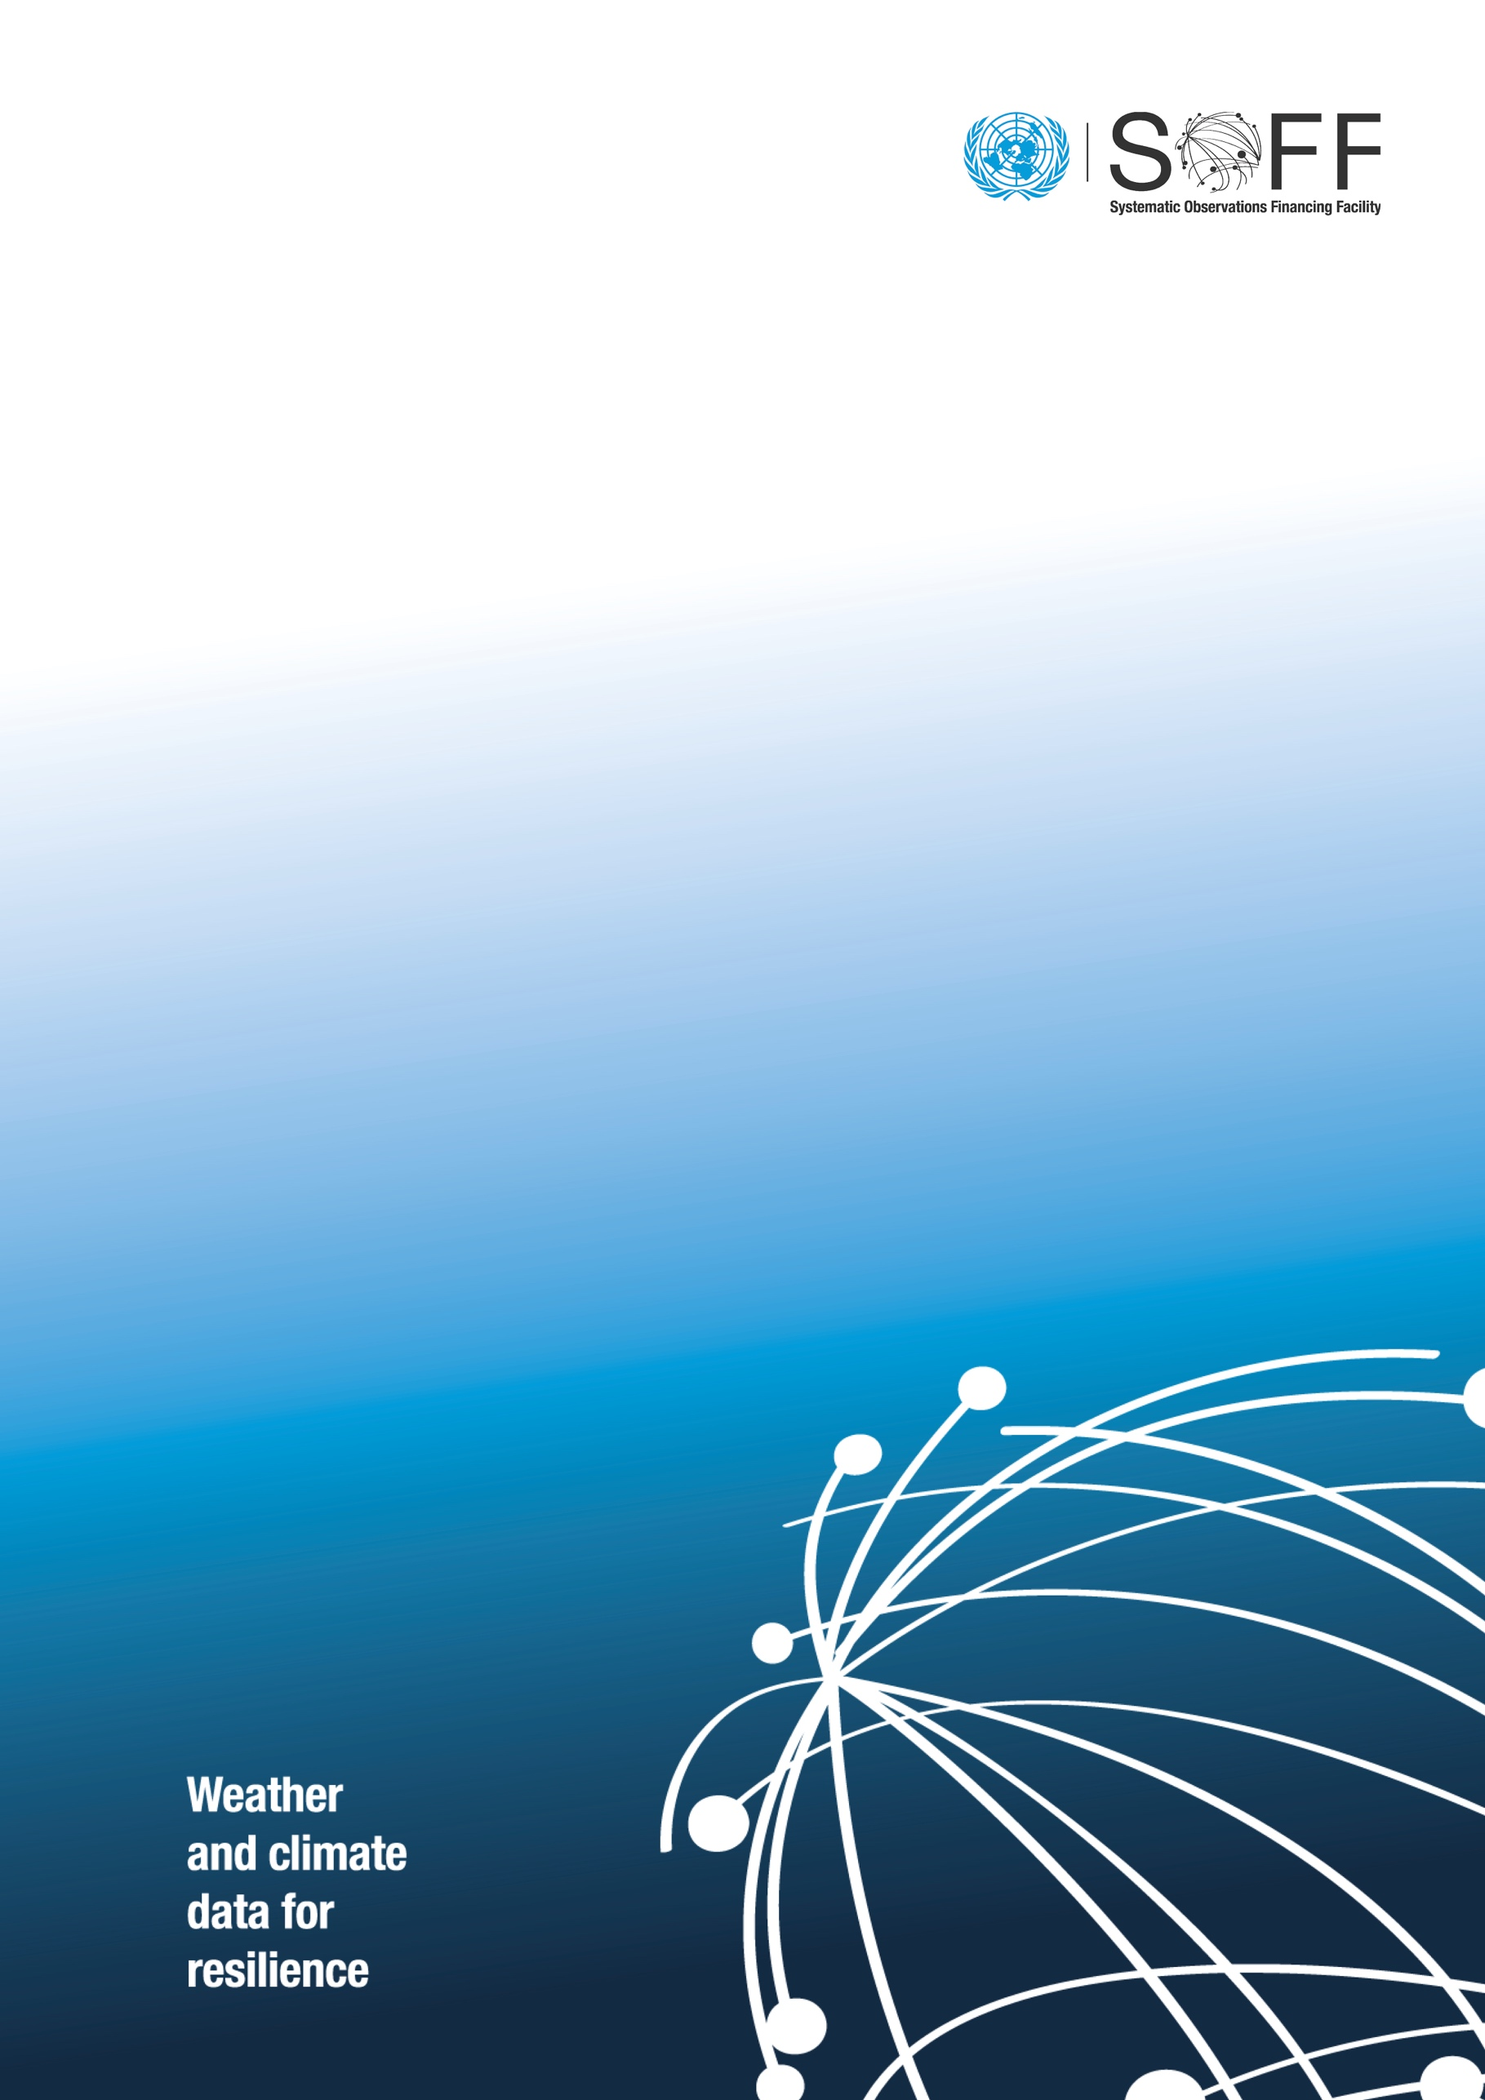
Investment Phase:
Annual Narrative Report

(country)
(year)
  - Systematic Observations
Financing Facility

General Information
Country
Implementing Entity
Agreement effectiveness date | Enter date of approval in the Gateway
Duration | Indicate number of months
Anticipated end date | Click to enter a date
Reporting period | From: Click to enter a date | To: Click to enter a date
Approved amount | USD
Disbursed amount | USD
Signature of Implementing Entity

Summary
Highlight main achievements during the reporting period, lessons learned, and any relevant information.

Progress of implementation
Output | Indicator | Target |  |  |  |  | Actual |  |  |  |  | Status | Milestones achieved | Challenges and risks
 |  | Y1 | Y2 | Y3 | Y4 | Y5 | Y1 | Y2 | Y3 | Y4 | Y5
1. GBON institutional and human capacity developed
1.1 National consultations, including with CSOs and other relevant stakeholders conducted | Add indicator as per approved funding request |  |  |  |  |  |  |  |  |  |  | Select an item
 | Add indicator as per approved funding request |  |  |  |  |  |  |  |  |  |  | Select an item
 | Add indicator as per approved funding request |  |  |  |  |  |  |  |  |  |  | Select an item
1.2 NMHS institutional capacity required to operate the GBON network developed | Add indicator as per approved funding request |  |  |  |  |  |  |  |  |  |  | Select an item
 | Add indicator as per approved funding request |  |  |  |  |  |  |  |  |  |  | Select an item
 | Add indicator as per approved funding request |  |  |  |  |  |  |  |  |  |  | Select an item
1.3 NMHS human capacity required to operate the GBON network developed | Add indicator as per approved funding request |  |  |  |  |  |  |  |  |  |  | Select an item
 | Add indicator as per approved funding request |  |  |  |  |  |  |  |  |  |  | Select an item
 | Add indicator as per approved funding request |  |  |  |  |  |  |  |  |  |  | Select an item
2. GBON infrastructure in place
2.1 New land-based stations and related equipment, ICT systems, data management systems and standard operating practices in place | # of new stations installed as per the GBON National Contribution Plan |  |  |  |  |  |  |  |  |  |  | Select an item
2.2 Improved land-based stations and related equipment, ICT systems, data management systems and standard operating practices in place | # of stations improved as per the GBON National Contribution Plan |  |  |  |  |  |  |  |  |  |  | Select an item
2.3 New upper air stations and related equipment, ICT systems, data management systems and standard operating practices in place | # of new stations installed as per the GBON National Contribution Plan |  |  |  |  |  |  |  |  |  |  | Select an item
2.4 Improved upper air stations and related equipment, ICT systems, data management systems and standard operating practices in place | # of stations improved as per the GBON National Contribution Plan |  |  |  |  |  |  |  |  |  |  | Select an item
3. Sustained compliance with GBON
3.1 GBON land-based stations’ commissioning period completed, country-specific standard cost for operations and maintenance established, and data sharing verified by WMO Technical Authority | # of stations commissioned as per the GBON National Contribution Plan |  |  |  |  |  |  |  |  |  |  | Select an item
3.2 GBON upper air stations’ commissioning period completed, country-specific standard cost for operations and maintenance established, and data sharing verified by WMO Technical Authority | # of stations commissioned as per the GBON National Contribution Plan |  |  |  |  |  |  |  |  |  |  | Select an item

Gender
Please indicate how the Gender Policy of your organization (Implementing Entity) was applied to SOFF Operations.

Social and environmental safeguards
Please indicate how environmental and social safeguards standards are observed in the execution of activities.

Civil society and private sector participation
Please indicate any engagements to date with civil society and private sector during Investment Phase implementation.

Complementary financing and leverage
Please indicate any complementarity with ongoing and future projects/programmes with other climate funds.

Implementation of grievance redress mechanism
If applicable, please provide description of any issues or complaints received, along with the current status of their resolution.

Success stories
Please share any success stories and links to news and publications relevant to Investment Phase implementation.

