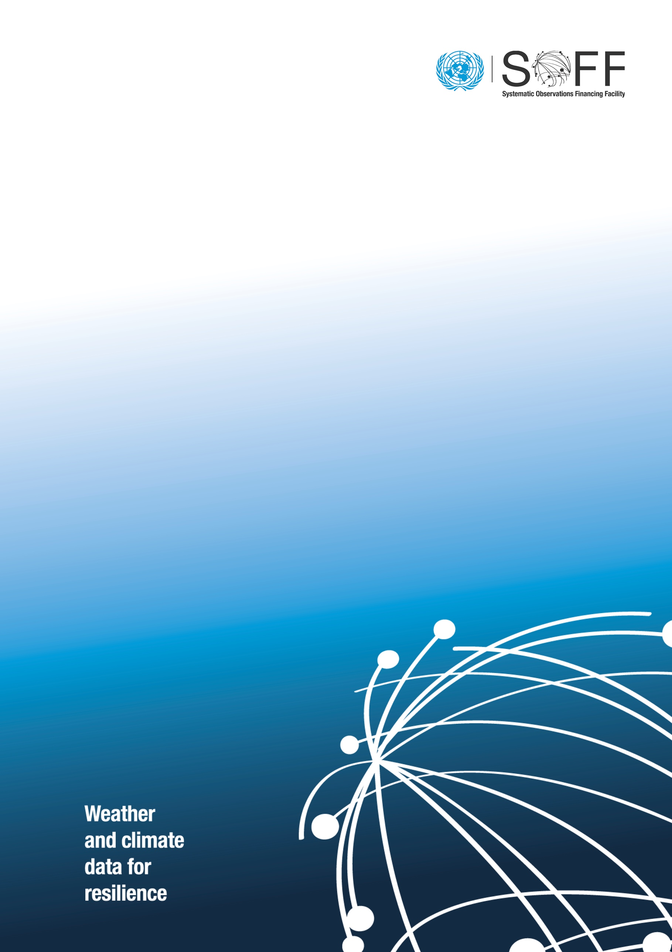(date and month) 2024

GBON National Contribution Plan

of (*beneficiary country name*)

Systematic Observations   
Financing Facility

**GBON National Contribution Plan**

**[Country Name]**

|  |  |
| --- | --- |
| **SOFF beneficiary country focal point and institution** |  |
| **SOFF peer advisor focal point and institution** |  |

**Table of contents**

GBON National Contribution Plan 2

Module 1. National Target toward GBON compliance 4

Module 2. GBON Business Model and Institutional Development 5

Module 3. GBON Infrastructure Development 7

Module 4. GBON Human Capacity Development Modul 9

Module 5. Risk Management Framework 10

Module 6. Transition to SOFF investment phase 11

Summary of GBON National Contribution Plan 12

Annexes (if any) 13

Report completion signatures 14

**Module 1. National Target toward GBON Compliance**

(Summarize the national target toward GBON compliance in the table below and provide the technical details as needed)

Table 1. GBON National Contribution Target

|  |  |  |  |  |  |  |
| --- | --- | --- | --- | --- | --- | --- |
| **Type of station** | **WMO GBON Global Gap Analysis, June 2023** | | | | **GBON National Contribution Target** | |
| **Target** | **Reporting** | **Gap** | | **To improve** | **New** |
| **To improve** | **New** |
|  | **[# of stations]** | | | | **[# of stations]** | |
| **Surface** |  |  |  |  |  |  |
| **Upper-air** |  |  |  |  |  |  |
| **Marine** | **\*when applicable** | | | | | |

(Add here a map of existing and proposed surface and upper-air stations with 200km/500 (**diameter**) km circles (500km/1000 km for SIDS) to indicate the coverage of the stations and provide the explanation as needed )

Figure 1. Map of existing and proposed surface and upper-air stations. Please use horizontal resolution as diameter = radius is half the horizontal resolution.

**Module 2. GBON Business Model and Institutional Development**

**2.1. Assessment of national governmental and private organizations of relevance for the operation and maintenance of GBON**

*Identify:*

* *Governmental stakeholders operating and acquiring meteorological observations or with the potential to support GBON;*
* *Private sector operators providing meteorological observations and data services in the country (for ship-based observations, identify fleet of ships government-owned or private and research owned) to install instrument packages)*

*Provide recommendation on how they could contribute to the implementation of the Plan and required activities to materialize the proposed partnerships:*

1. *Existing partners and relationships;*
2. *Potential new partners and their roles.*

**2.2. Assessment of potential GBON sub-regional collaboration**

*Identify neighboring countries and regional organizations of relevance for potential sub-regional collaboration.*

*Provide recommendations for potential optimization of the observing network through sub-regional network design and other sub-regional partnerships for the implementation of the Plan.*

**2.3. Assessment of a business model to operate and maintain the network**

*Assess the current funding sources, budget allocations and financial status related to operations of the NMHS-owned observing network.*

*Provide recommendation of a business model for public-private collaboration for the implementation of the Plan, based on the SOFF private sector business models,[1] including:*

1. *Recommendation of a business model to operate and maintain the GBON infrastructure, considering arrangements for SOFF financial support during the Compliance phase*
2. *Identify potential private sector operators depending on the proposed business model*
3. *Develop a financial plan for operating the modernized infrastructure, including considerations on the total cost of ownership*

**2.4. Assessment of existing national strategies and projects related to observing networks**

*Review the national strategies for establishing and improving observing networks*

*Review of existing or planned hydromet development projects related to GBON*

*Provide recommendation on activities to ensure consistency and complementarity of current and planned investments and development projects of relevance for GBON*

**2.5. Review of the national legislation of relevance for GBON**

*Review the national legislation related to responsibility for measuring and providing weather observations related to GBON.*

*Review the legislation related to procurement, importation and customs processes of relevance for the proposed Plan's activities and investments.*

*Provide recommendation on how to address any constraints related to the national legislation required to implement GBON.*

**Module 3. GBON Infrastructure Development**

**3.1. Design the surface and** **upper-air observing network and observational practices**

*Provide recommendation on a harmonized observing network design, including siting and instrumentation of new and improved stations, including:*

1. *A map of observing network distribution and a list of the required new or rehabilitated GBON stations;*
2. *A list of observation instruments and systems per site; and*
3. *Investments and activities needed for the installation of new stations and the improvement of existing stations*
4. *Observational practices defined per network*
5. *Preliminary maintenance plan for existing and improved/new stations, including calibration practices / - equipment / - facilities*
6. *Technical specification for new instruments and observing systems for the procurement process*
7. *Considerations for stations’ security, constant power supply, communication and related contingencies (risks can be incorporated in section 5).*

**3.2. Design of the ICT infrastructure and services**

*Provide recommendation on ICT infrastructure and services design and solutions on data transmission from an observing station to the national real-time data management system and GTS and WIS 2.0, including:*

1. *Detailed description of the ICT infrastructure and services design*
2. *Technical specifications for the data collection system from the observing station to the collection point*
3. *Technical specifications of the data services (compatible with the requirements of WIS 2.0)*
4. *Detailed description of the measures to ensure resilience and continuity of the full data processing chain*

**3.3. Design the data management system**

*Provide recommendation on requirements for a data management system aimed to provide access to data used by operational applications on a real-time basis and the capability to deliver data to a Climate Data Management System (CDMS) for long-term archiving purposes. The system should provide the following:*

1. *Short-term data storage and access through the services and protocols required by applications for national and international operational activities*
2. *Acquisition of data to and from WIS/GTS, WIS 2.0 and other national or international sources required for operational activities*
3. *Data delivery to the national CDMS*
4. *Discovery and descriptive metadata management*
5. *Monitoring of data, processing and services*

**3.4. Environmental and sustainability considerations**

*Recommend pragmatic approaches and measures for environmentally responsible design and evolution of the national networks to achieve GBON requirements, including:*

1. *Development and use of specifications that consider environmental sustainability for procurement of measurement instrument equipment to meet the GBON requirements*
2. Integration of sustainability considerations for the management of operations of GBON stations, including installation, calibration, and maintenance
3. Careful material selection for the development, shipping and day-to-day operations of GBON stations, with a focus on developing and using reusable instruments and sustainable methods of observation (e.g., elimination of single-use plastics).

**Module 4. GBON Human Capacity Development Modul**

**4.1. Assessment of human capacity gaps**

*Provide a summary of staff skills, education levels, and capacity gaps for technicians, experts, and management, including Port Meteorological Officers (PMO) when applicable, gender balance and gender opportunities.*

**4.2. Design capacity development activities for technical staff**

*Provide recommendation on training activities and recruitment for technical staff, including:*

1. *Instrument and station maintenance at site*
2. *Calibration and maintenance at the workshop*
3. *Network monitoring*
4. *ICT system operations*

**4.3. Design capacity development activities for senior management**

*Provide recommendation on training activities and recruitment for management in*

1. *Strategic and financial planning*
2. *Project management*

**4.4. Gender and CSOs considerations**

*Provide recommendations on activities, consultations, and areas of collaboration for the implementation of the Plan to ensure active CSOs participation and promotion of gender balance and gender opportunities.*

**Module 5. Risk Management Framework**

**5.1 Assess the risks of the observing network and propose mitigation measures**

*Based on the SOFF Risk Management Framework, identify risks and recommend a risks management framework, including:*

1. *Identification and analysis of risks*
2. *Mitigating measures and responsible*
3. *Monitor and evaluation*

**Module 6. Transition to SOFF investment phase**

*This module involves supporting the beneficiary country and the IE in preparing the Investment phase funding request based on the recommendations provided in the Plan.*

*Please provide any additional recommendation relevant for the translation of the National Contribution Plan into an Investment Phase Funding Request.*

**Summary of GBON National Contribution Plan**

*Provide summary of GBON National Contribution Plan by filling this table*

|  |  |
| --- | --- |
| **Components** | **Recommended activities** |
| **Module 2.**  GBON business model and institutional development | 1. |
| 2. |
| 3. |
| 4. |
| 5. |
| **Module 3.**  GBON infrastructure development | 1. |
| 2. |
| 3. |
| 4. |
| 5. |
| **Module 4.**  GBON human capacity development | 1. |
| 2. |
| 3. |
| 4. |
| 5. |
| **Module 5.**  Risk Management | 1. |
| 2. |
| 3. |
| 4. |
| 5. |
| **Module 6.**  Transition to SOFF investment phase |  |

**Annexes (if any)**

**Report completion signatures**

|  |
| --- |
| **Peer Advisor signature** |
| **Beneficiary Country signature** |
| **WMO Technical Authority signature** |

1. See chapter 4 of the [Operational Guidance Handbook](https://www.un-soff.org/document/soff-operational-guidance-handbook/) on SOFF private sector archetypal business models